**Final Project**

**HR ANALYTICS - EMPLOYEE ATTRITION ON IBM**

**-------------------------------------------------------------------------------------------------------------------**

Prepared for:

DSS 665 R Statistical Language

Dr. Nicolle Clements

**-------------------------------------------------------------------------------------------------------------------**

Prepared by:

Kanivalavan Venkatesan

Saint Joseph’s University

December 11, 2018

**Objective**

The objective of this project is to **predict the employee attrition** using various classifications algorithms like Decision Tree, Logistic Regression, and Random Forest and measure the performance of the models using various metrics such as precision, recall, and AUC. I wouldn’t narrow down only in prediction by applying some machine learning algorithms. My journey of this project would include all the data mining life cycles such as **data understanding/ exploration, data preparation, modelling and evaluation etc**. using the R. Let’s jump into my journey to see how we could use R from data exploration to model evaluation.

**About Data**

|  |  |  |  |  |  |
| --- | --- | --- | --- | --- | --- |
| Education | 1 'Below College' | 2 'College' | 3 'Bachelors' | 4 'Master' | 5 'Doctors' |
| EnvironmentSatisfaction | 1 'Low' | 2 'Medium' | 3 'High' | 4 'Very High' | |
| JobInvolvement | 1 'Low' | 2 'Medium' | 3 'High' | 4 'Very High' | |
| JobSatisfaction | 1 'Low' | 2 'Medium' | 3 'High' | 4 'Very High' | |
| PerformanceRating | 1 'Low' | 2 'Good' | 3 'Excellent' | 4 'Outstanding' | |
| RelationshipSatisfaction | 1 'Low' | 2 'Medium' | 3 'High' | 4 'Very High' | |
| WorkLifeBalance | 1 'Bad' | 2 'Good' | 3 'Better' | 4 'Best' | |

I used the IBM HR Analytics dataset which is available in Kaggle. The dataset has **35 columns**, in which **‘Attrition’** is the response variable and rest of the columns are independent variables. The response variable which I am going to predict contains the values of **‘No’** (Employee stayed) and **‘Yes’** (Employee left). This dataset contains both **numeric** and **categorical** variables. Age, Gender, Education, Monthly Income, Department, Daily rate are some of the variables in the dataset. Below is the list of labels for some of the categorical variables,

**Data Exploration/ Analysis**

Let’s do the exploratory data analysis using some descriptive statistics and charts to better understand the data. This dataset contains **1470 observations** with **35 variables.** The target variable is ‘Attrition’ which has the value of ‘No’ and ‘Yes’.



Below is the descriptive statistics to understand the levels, how the values are ranged in each variable. To explore on some the variables, the target variable ‘Attrition’ has 1233 observation for the class ‘No’ and only 237 observations for the class ‘Yes’. This indicates the **imbalanced class problem**, which I will deal in the later part of my analysis. We have age group from 18 to 60, monthly income ranges from $1009 to $19999. Looking at the some of the variables like **‘EmployeeCount’**, **‘Over18’**, and **‘StandardHours’**, we can understand that these variables won’t have any impact of the analysis, since all of these variables have same values for all the records. Hence, these variables are removed from the dataset along with ‘EmployeeNumber’ which is an identifier variable.

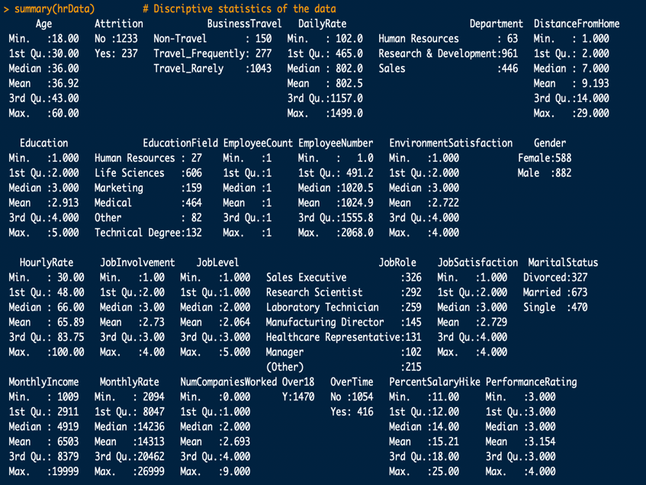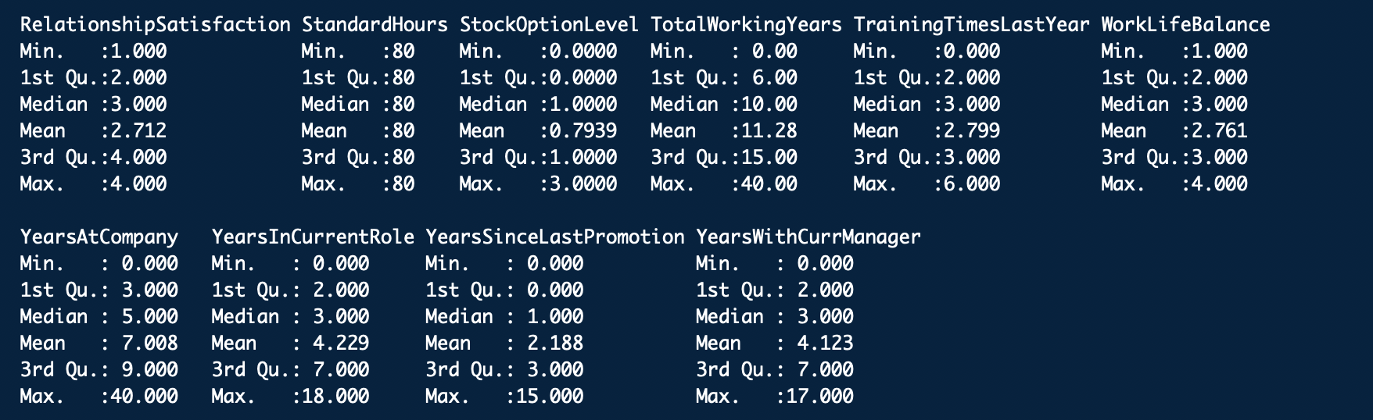

*Missing values*

The most important factor to analyze about the dataset is ‘missing values’, since it has high impact on making the inference or model biased. If we have more missing values for a particular variable or more of observations with null values for an important variable we use in the model, then there is high probability that the model could be biased. Fortunately, I **don’t have any missing values** in my dataset.



*Distribution of independent variables*

Now we see the distribution of few of the numeric variables. From the below distribution plot, we could see that people who left the organization fall in the age group of 25-35 and those who get less monthly income are more like to leave the company. This indicates **age** and **monthly income** has a high impact on attrition rate.

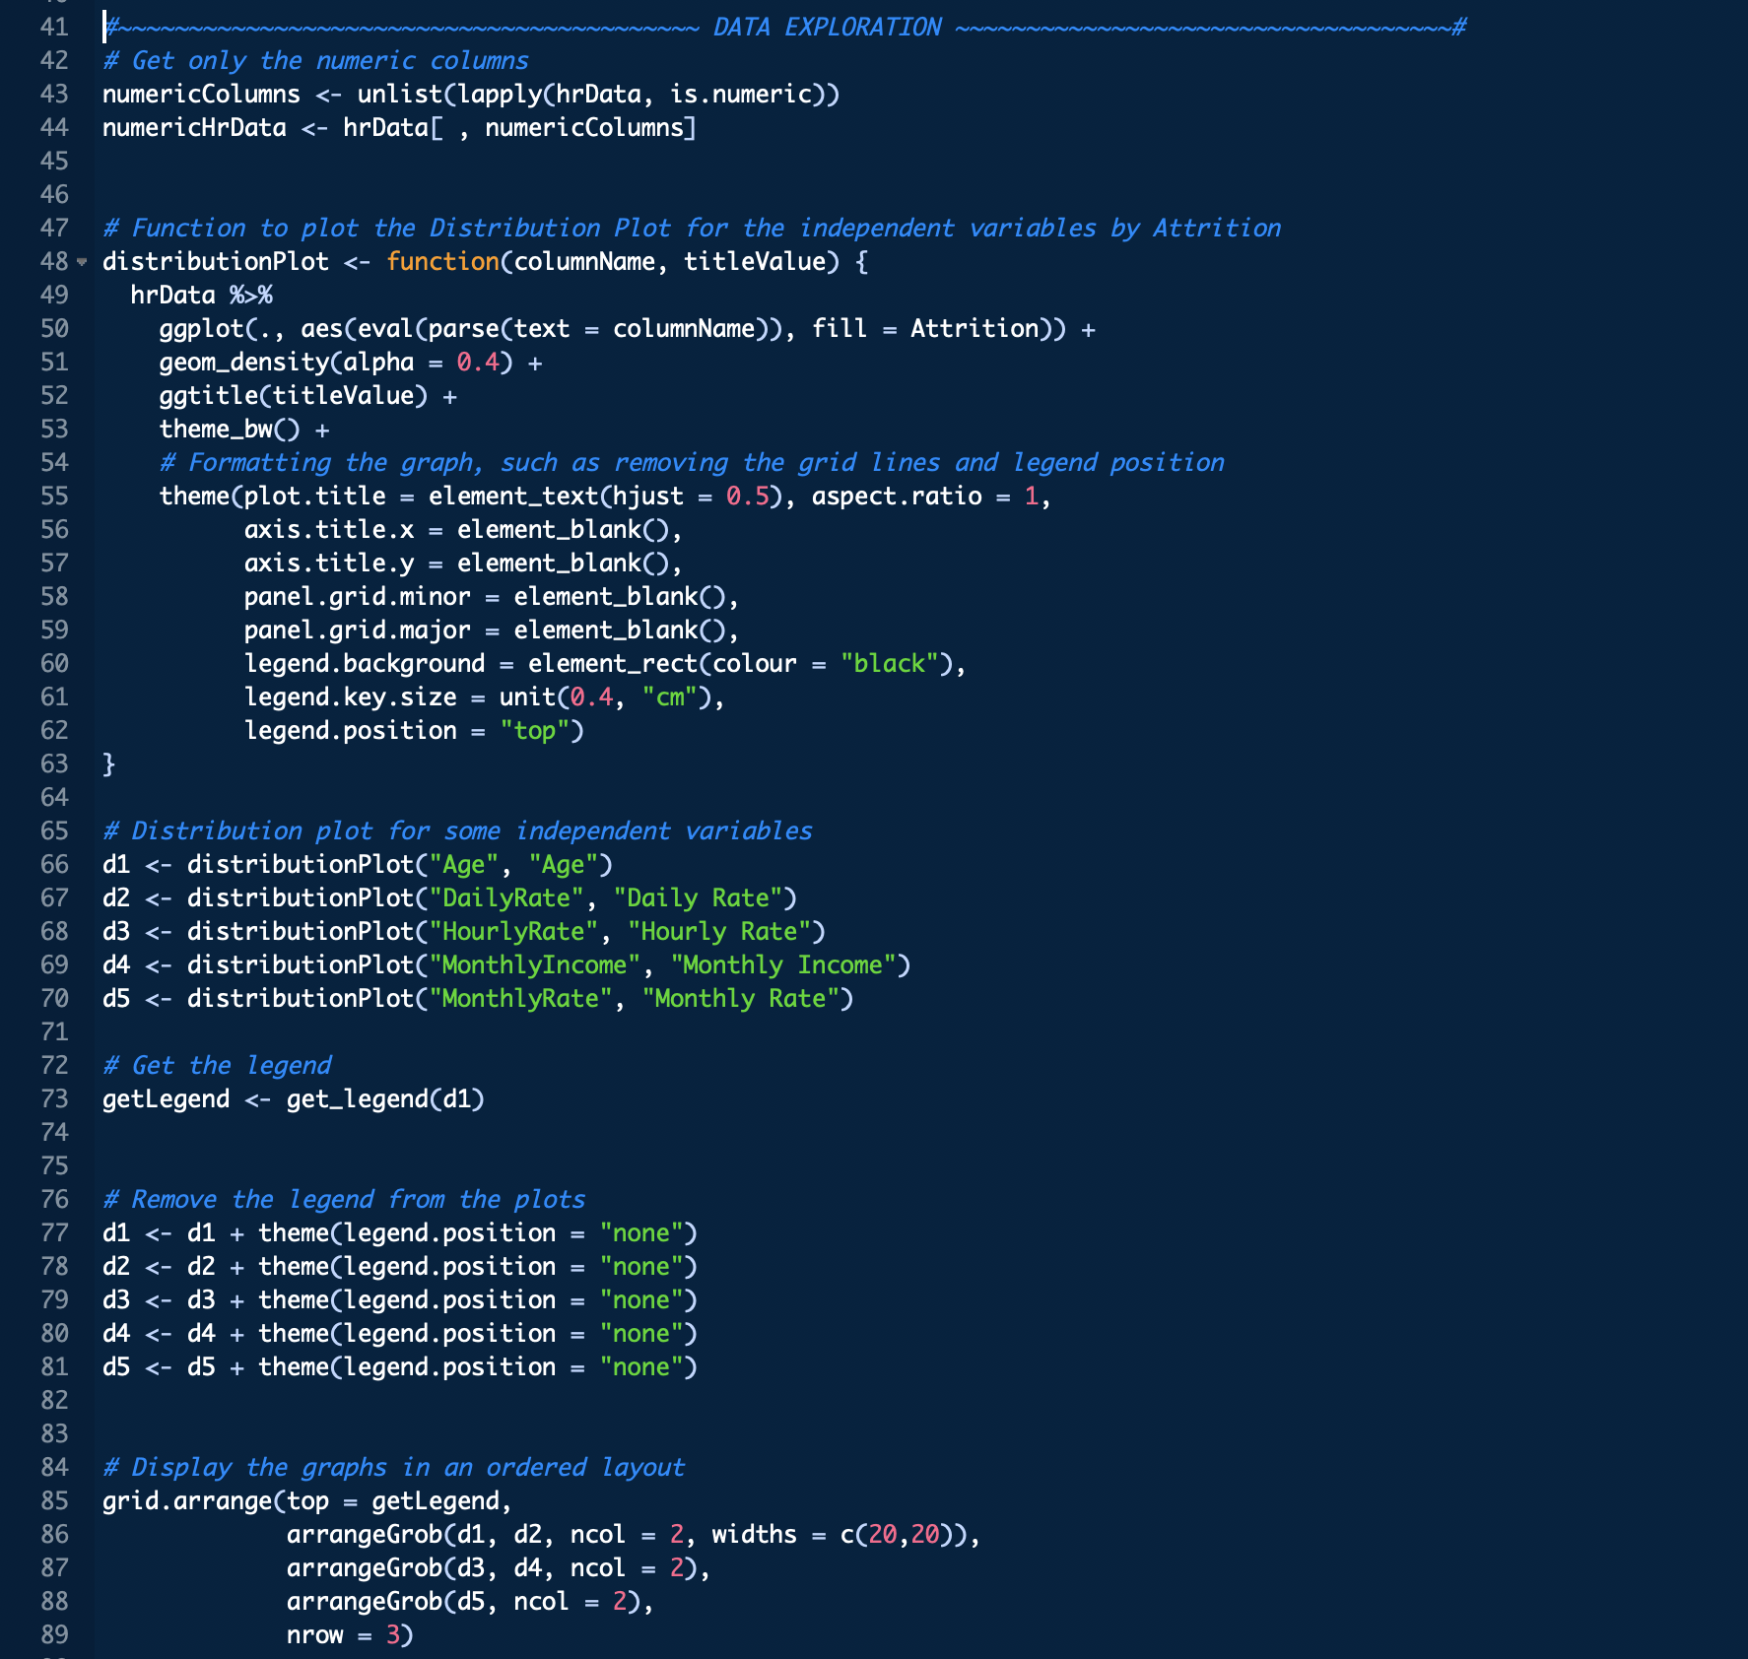

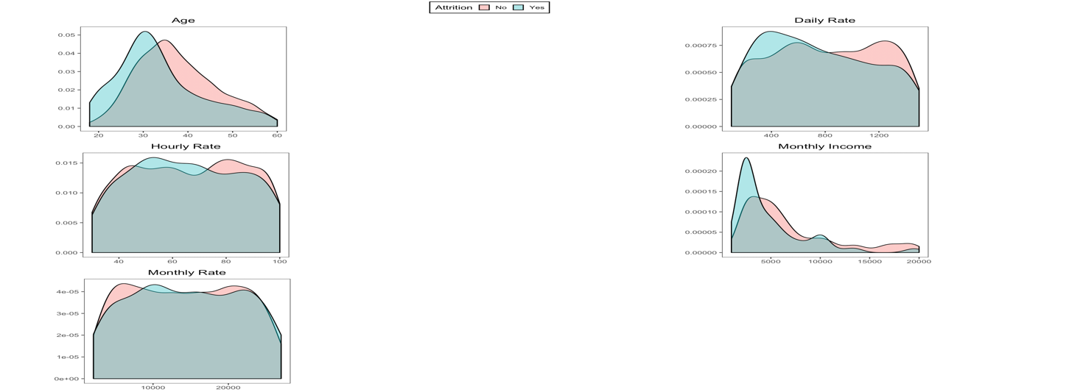

To understand how the variables, impact the attrition rate, lets quickly analyze the below visuals.

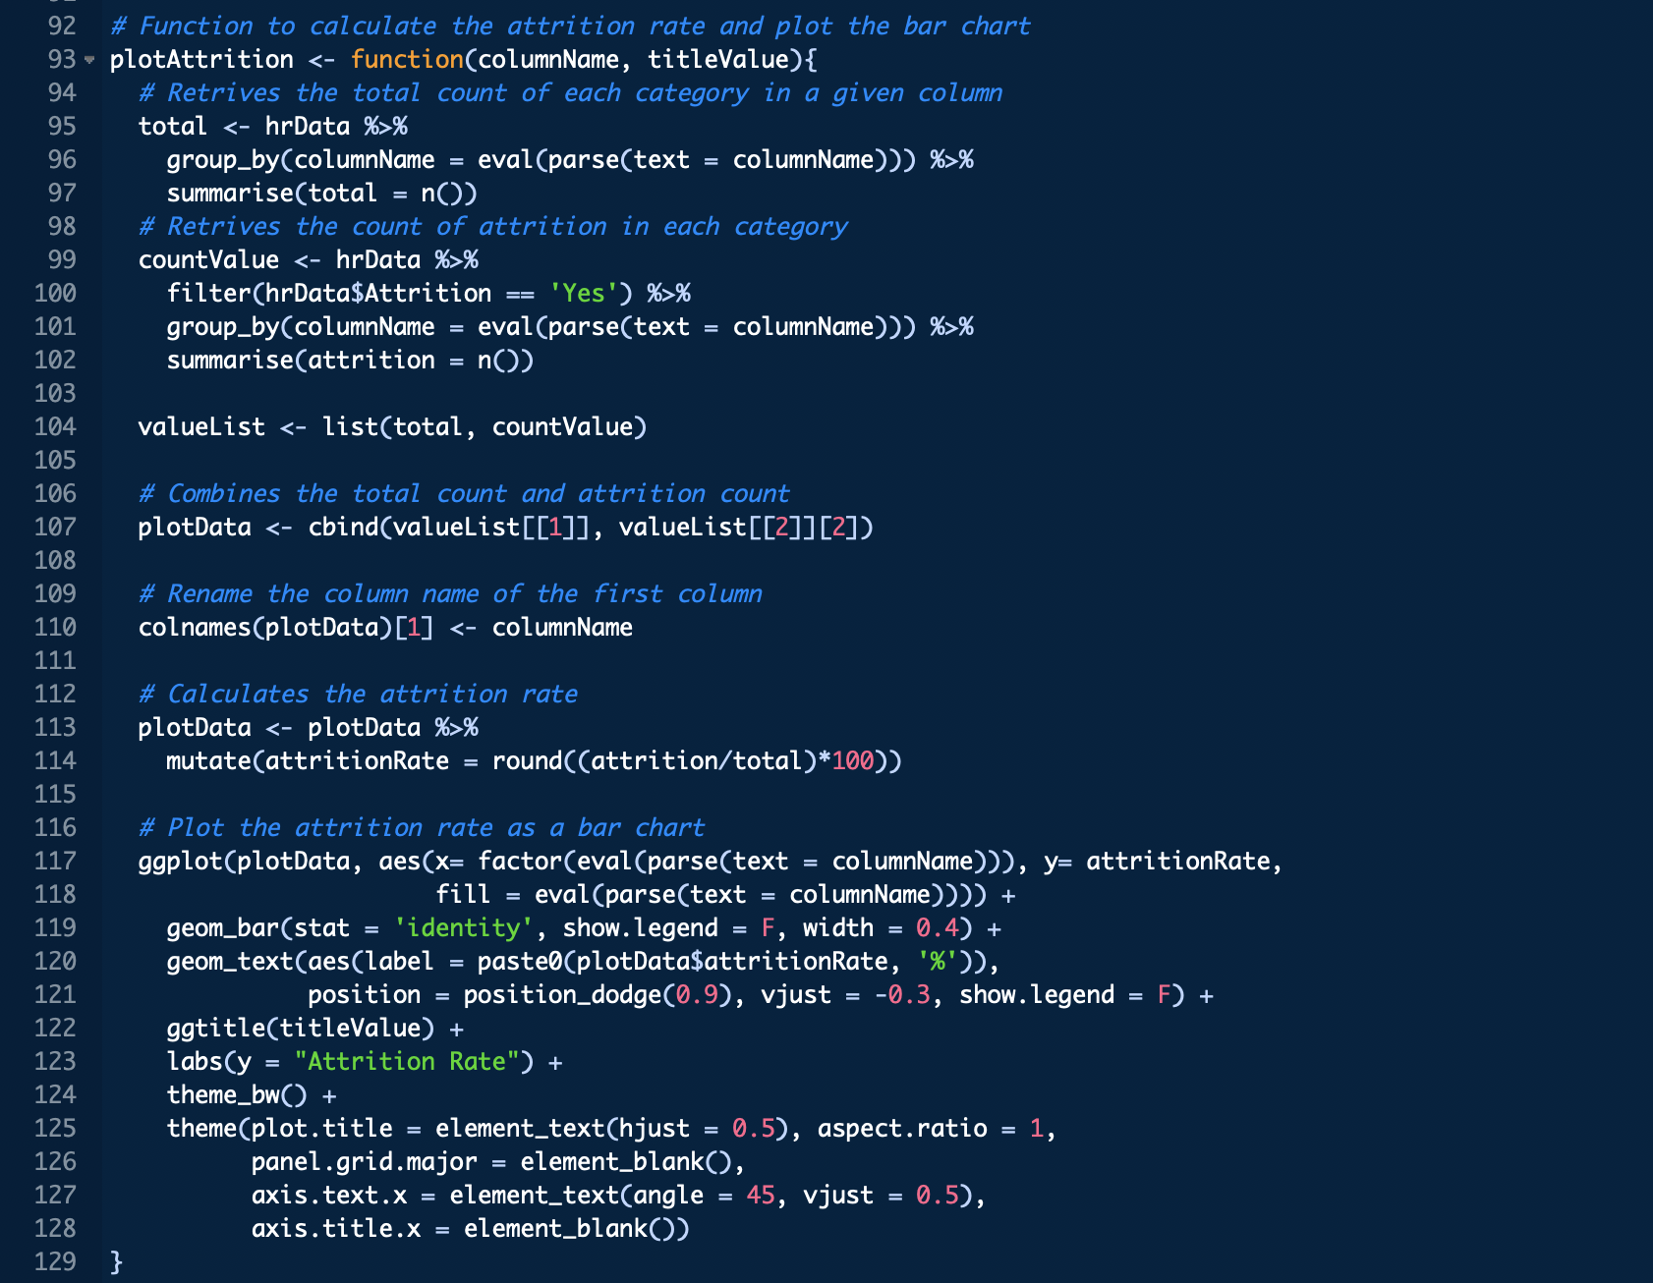

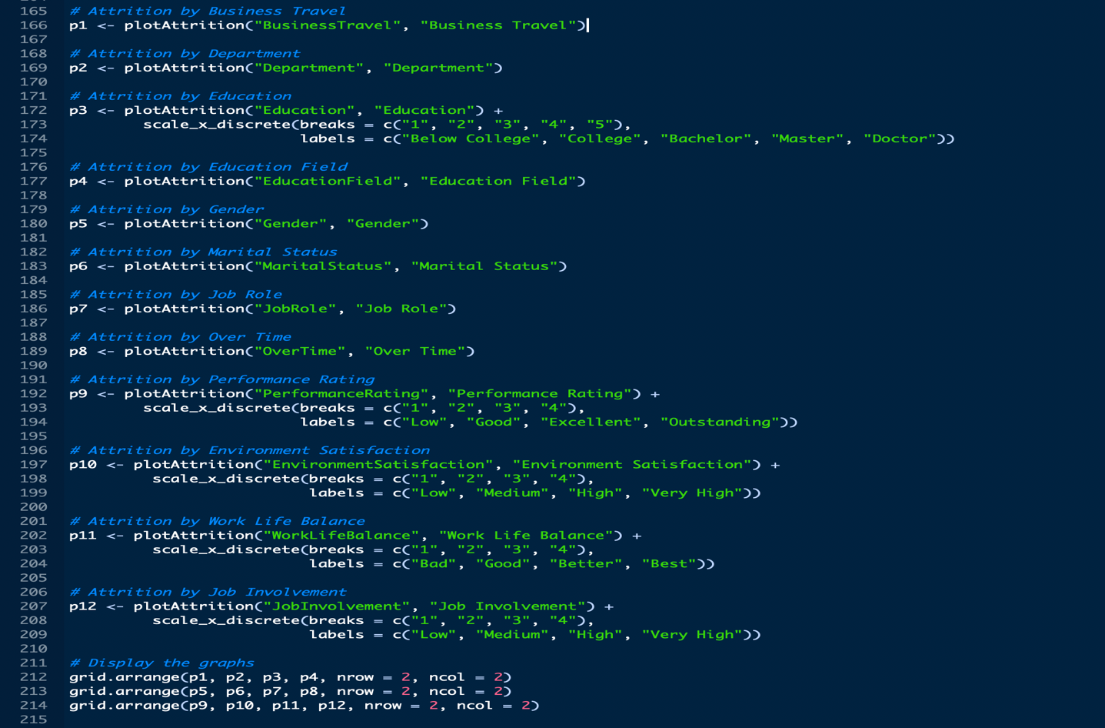

From the below graphs we could see, people don’t like **frequent business travel**. Attrition rate is high if they travel most. Also, HR should analyze, why the attrition rate is high in the **sales department**. Attrition rate for **bachelor’s degree** is comparatively high after ‘Below college’. The reason could be, they might have decided to pursue their higher studies. There is more attrition from the educational field of HR, Marketing, and Technical Degree. Those who are **singles** will frequently switch their jobs to increase their income and they are ready to take a risk to grab the new opportunities. They don’t care about job security.

Nobody likes the **overtime** and hence the attrition rate is more for who do overtime. Attrition rate for **sale representatives** is double the rate compared to other job roles. Hence, HR should focus seriously on that department.

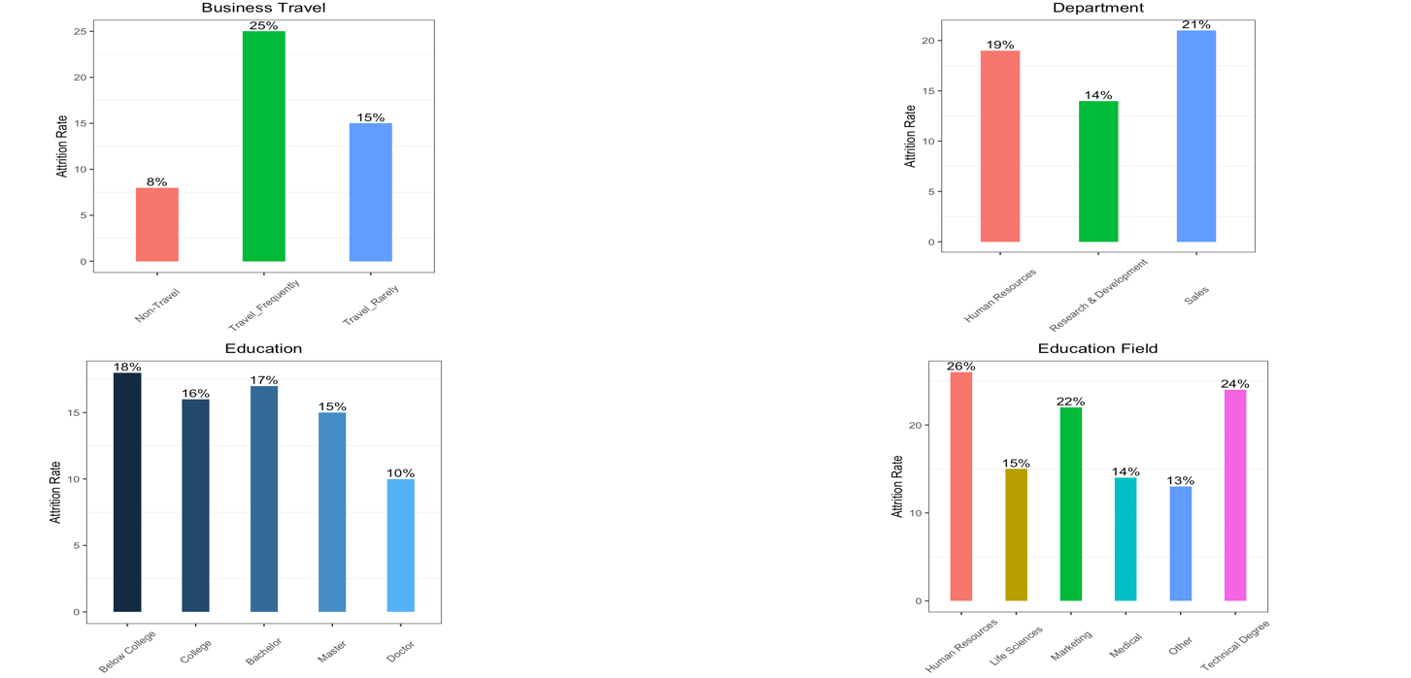

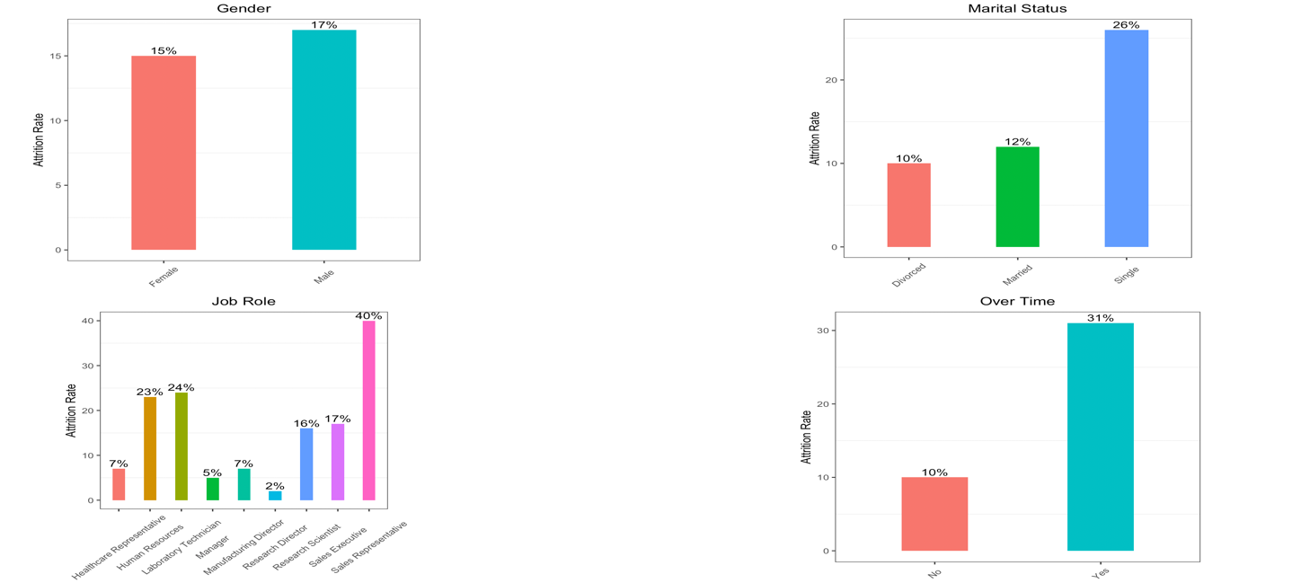

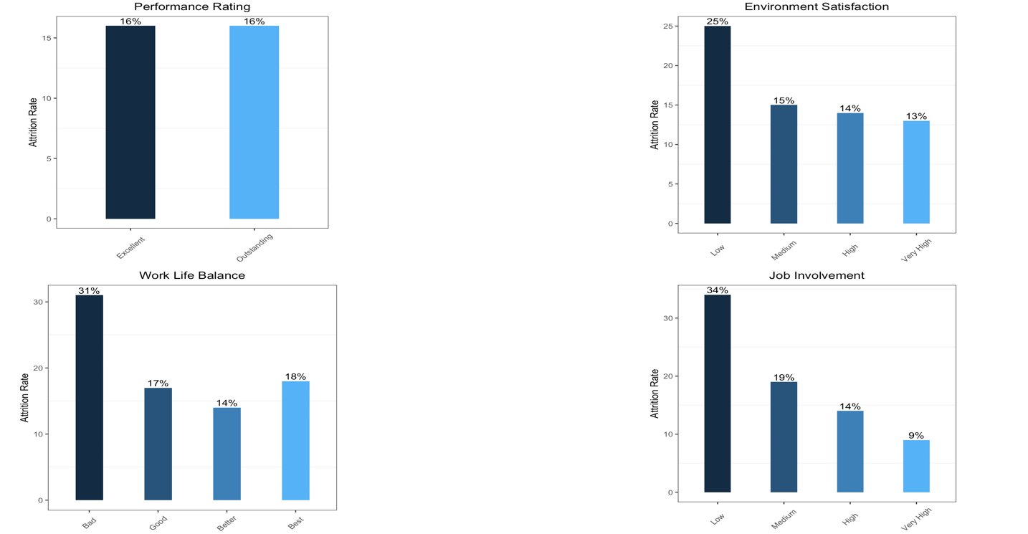

It’s obvious from the above graph that the person who have **less work life balance**, **less job involvement**, and less satisfaction in their work culture will more likely to leave the organization. Performance rating seems to have no impact on the attrition.

People in the age group of 25 to 35 tend to new jobs, new careers, and more income. Hence the attrition rate is almost doubled in this group. Income has more impact on attrition rate. As we can see in the below plots, those who earns less left the company compared to those who earns more. As the job level increases, income increases which show high correlation between these to factors. People who are in low levels and earns less leave the company which is evident form monthly income Vs job level graph.

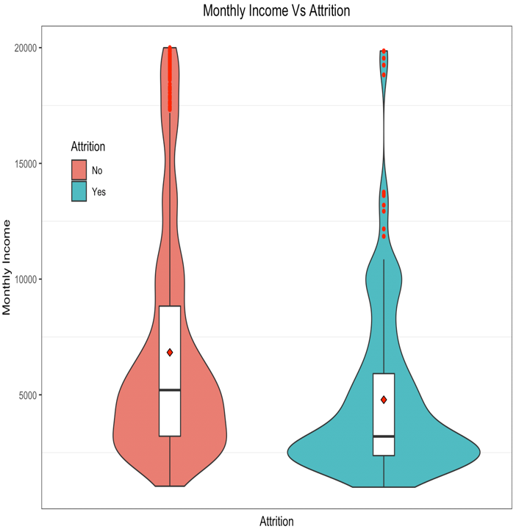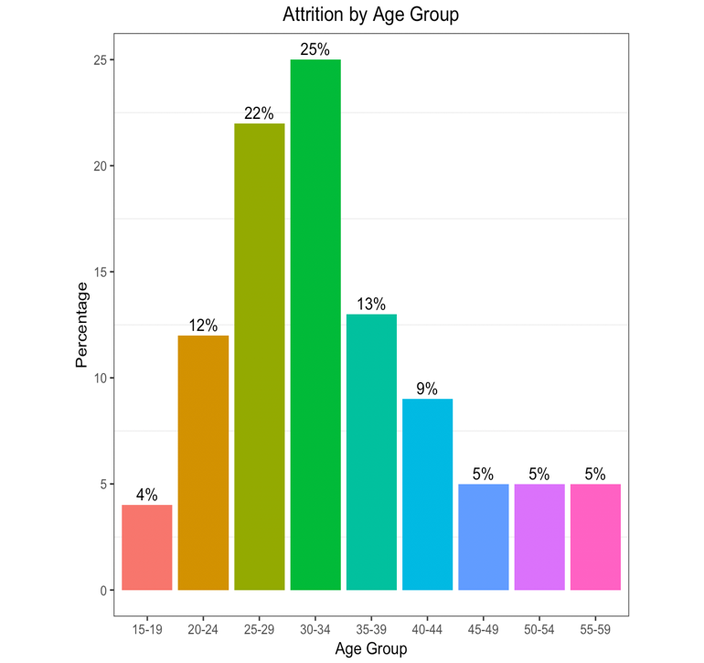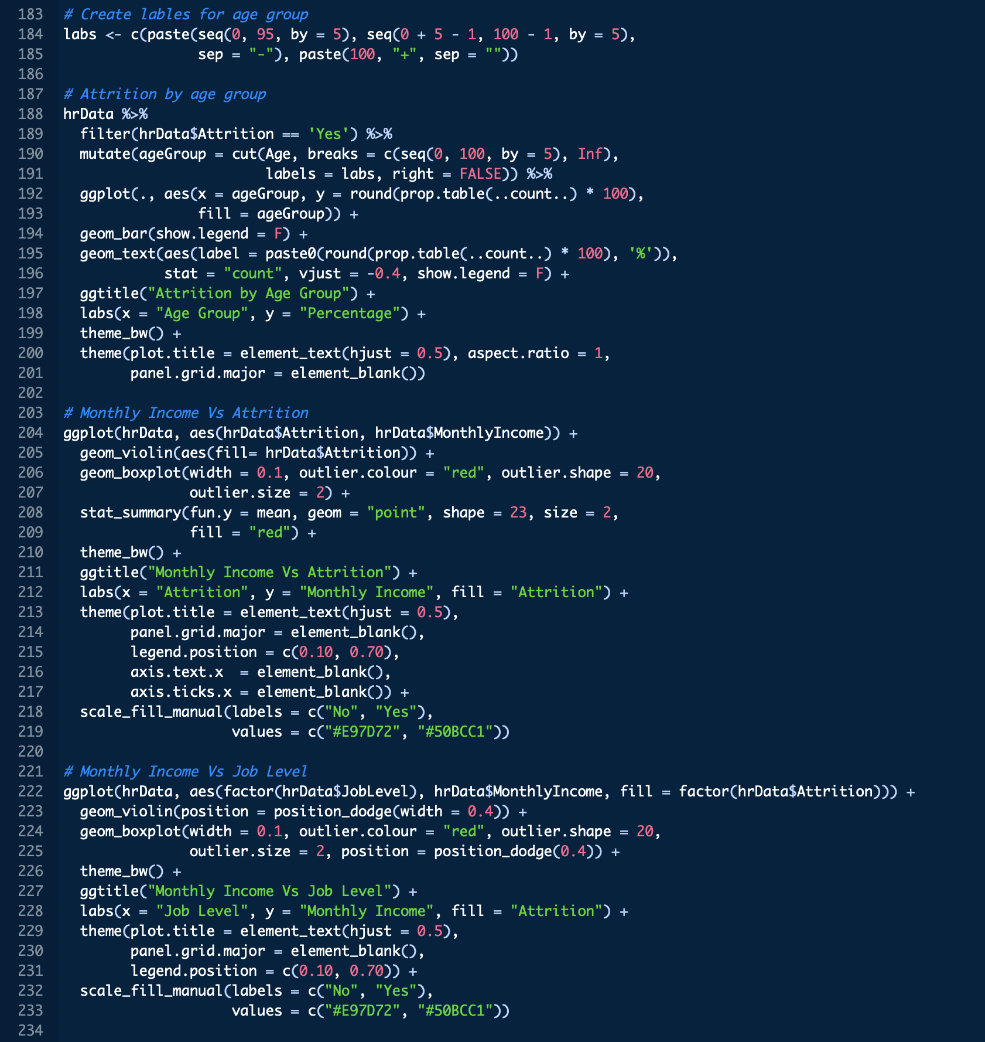

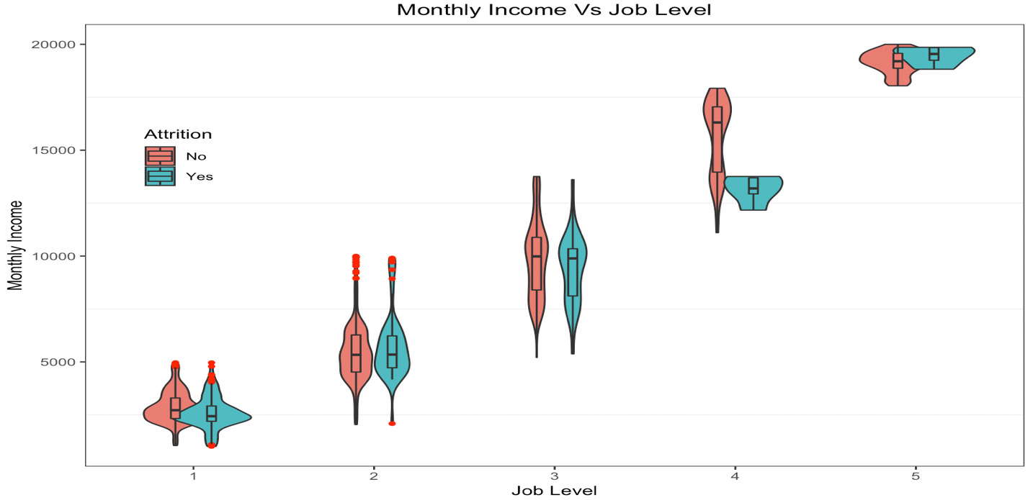

*Correlation check*

Before building the regression models, it is important to check the correlation between the independent variables as it makes the model estimates unreliable. From the below correlation plot, we could see that ‘JobLevel’ is highly correlated with ‘MonthlyIncome’ (0.95), ‘TotalWorkingYears’ (0.78), ‘Age’ is correlated with ‘TotalWorkingYears’ (0.68), and ‘PerformanceRating’ (0.77) and ‘PercentSalaryHike’ are correlated. So, this issue needs to be addressed before building the model. I used **‘Principal Component Analysis’** to deal with multicollinearity and feature engineering which is covered in the later part in this paper.

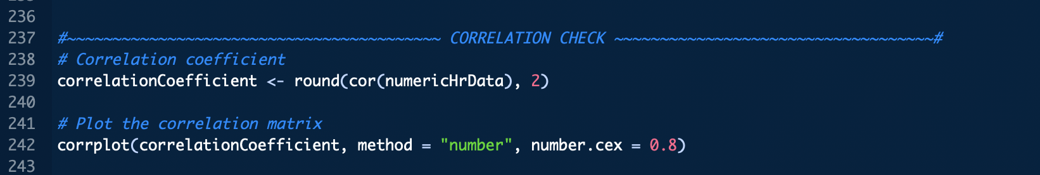

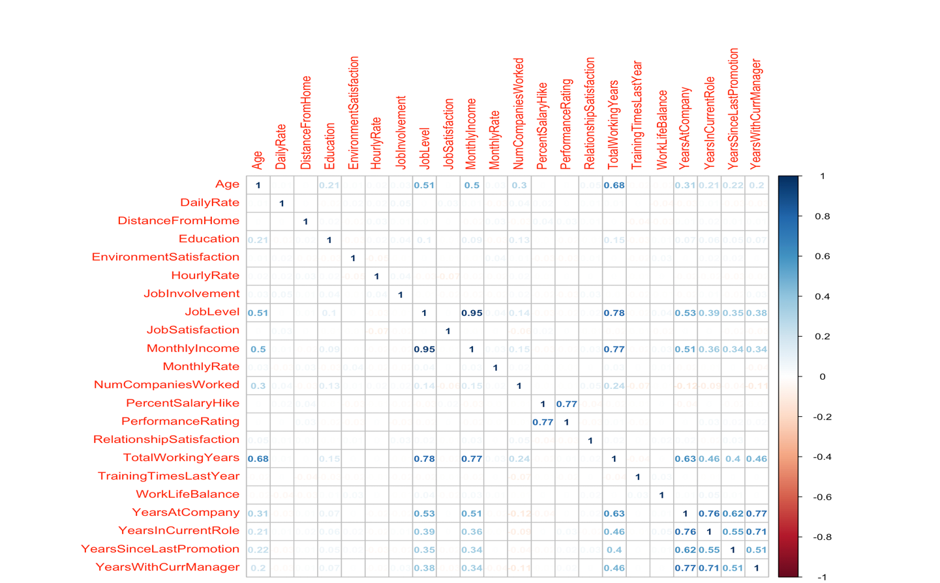

**Data Preparation**

I split the data into two parts. One for training the model and another for testing the model. I used sampling technique to split the data set into 80:20 ratio. Before splitting the dataset, I set the seed to generate the same sampling. The training dataset has 1182 rows and 30 columns. The test dataset has 288 observations.

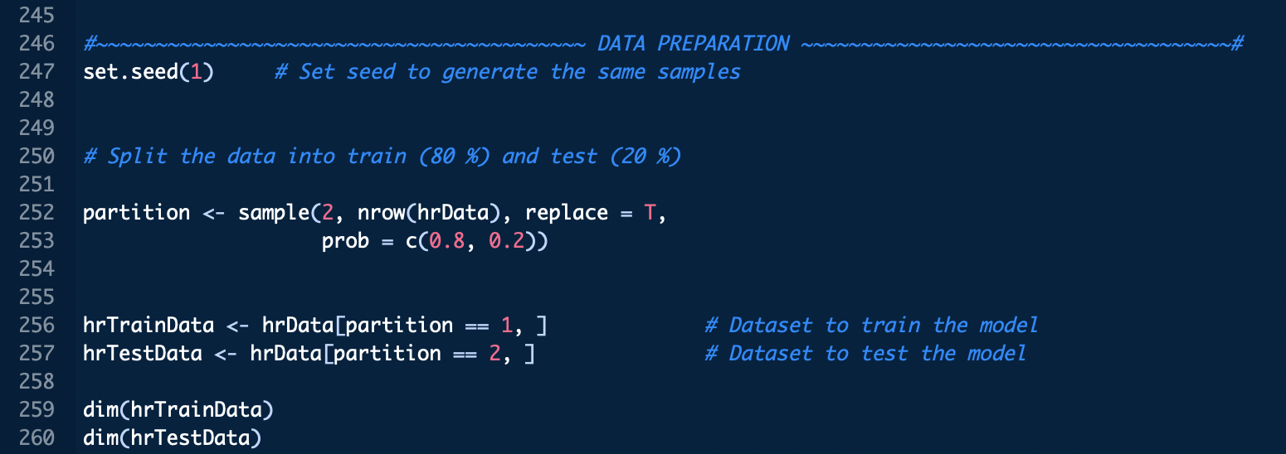

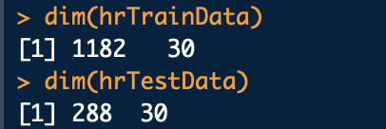

*Imbalanced data*

The target variable in the train dataset has 84% cases for who stayed in the organization (‘No’) but only 16% of cases for who left the organization (‘Yes’). Hence, it is an imbalanced data. The class ‘No’ outnumbered the class ‘Yes’. It is an important issue to deal before building the model as the accuracy would be impacted and the model will be biased towards majority class. There are various techniques like **over sampling**, **under sampling**, **synthetic data generation** etc. are widely used to handle imbalanced dataset. In this project I used oversampling technique to balance the training dataset. After this technique we can see that we have equal number (**993**) of observations from the both the classes.

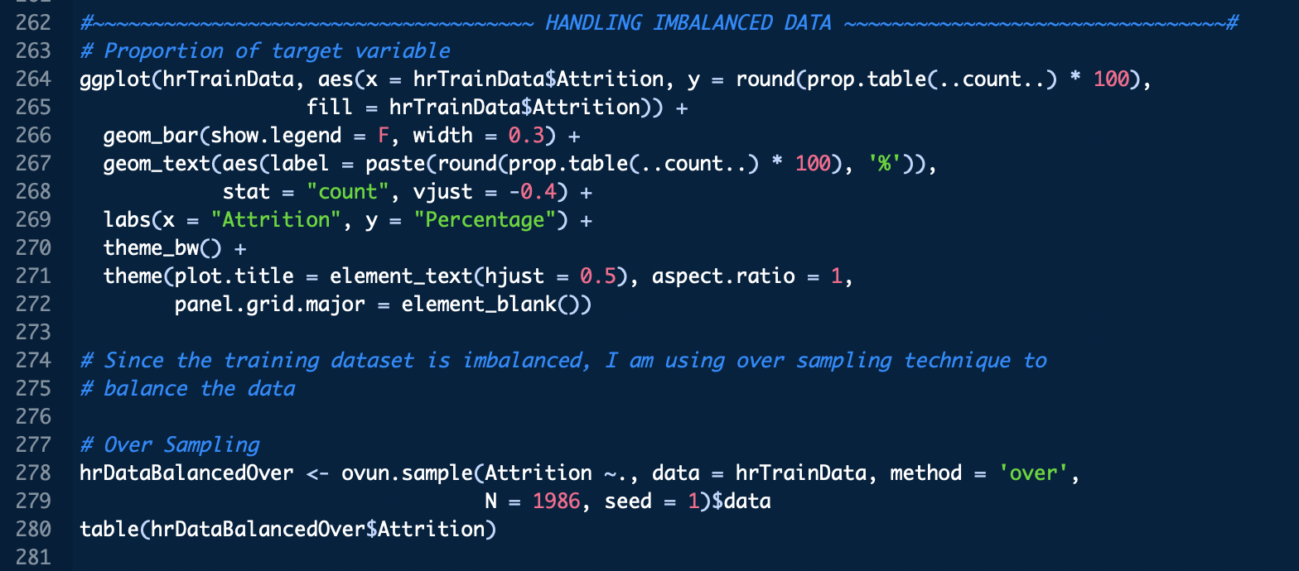

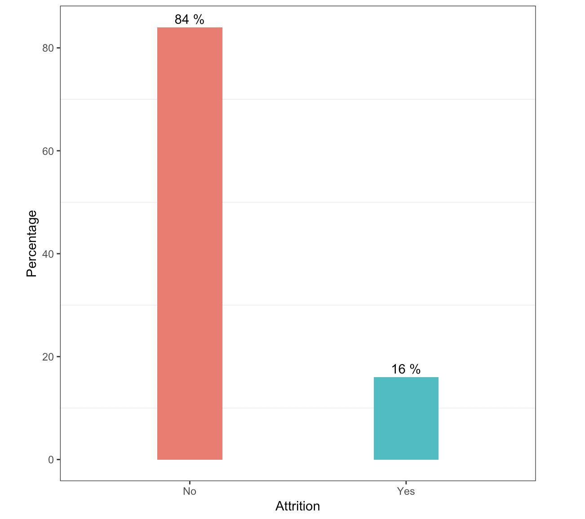

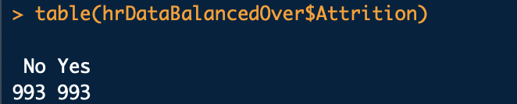

*Encoding the categorical variables*

Now the data is balanced, the next step is to deal with the multicollinearity and reduce the features. As stated earlier in the analysis, there seems to be correlation between some of the independent variables. I have used PCA to deal with this issue. But doing PCA require all the variable should be numeric. That’s why dummy variable comes into picture here. I have **encoded all the independent variables** using dummy variables.

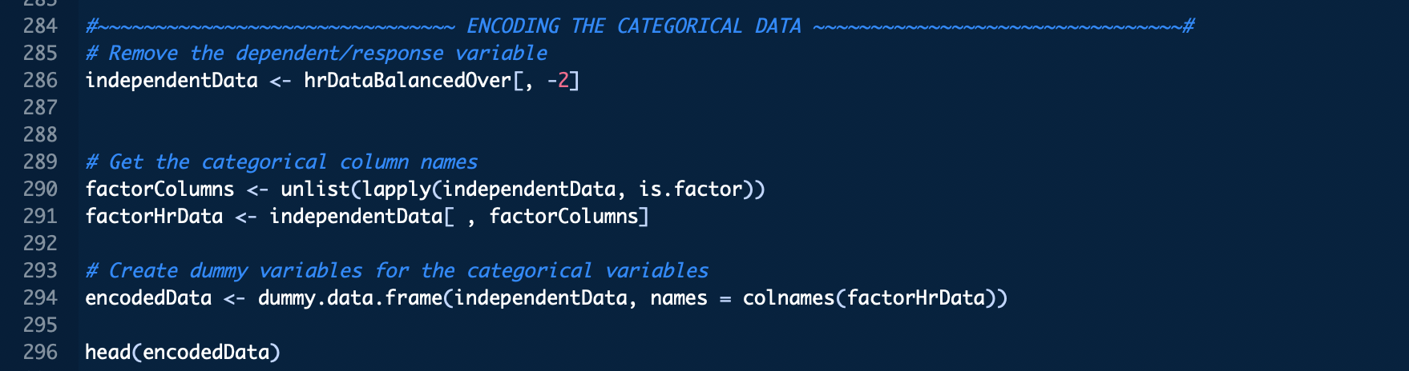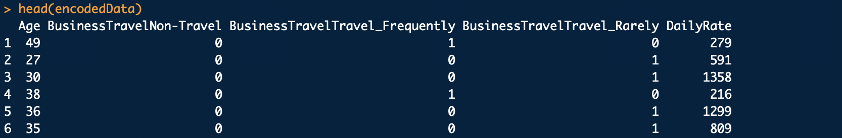

*Principle component analysis*

I split the encoded data into two parts, one to create the training dataset with PCA and another to create test dataset with PCA. Then I applied the PCA technique to the train dataset and computed the proportion of the variance explained by each component. Then plotted the scree plot to find the optimal number of components, which helped me to narrow down to first 30 components as around **98% of variance** is explained by them. Then combined those first 30 components with the target variable to build the final train dataset. Also, transformed the test data with PCA components.

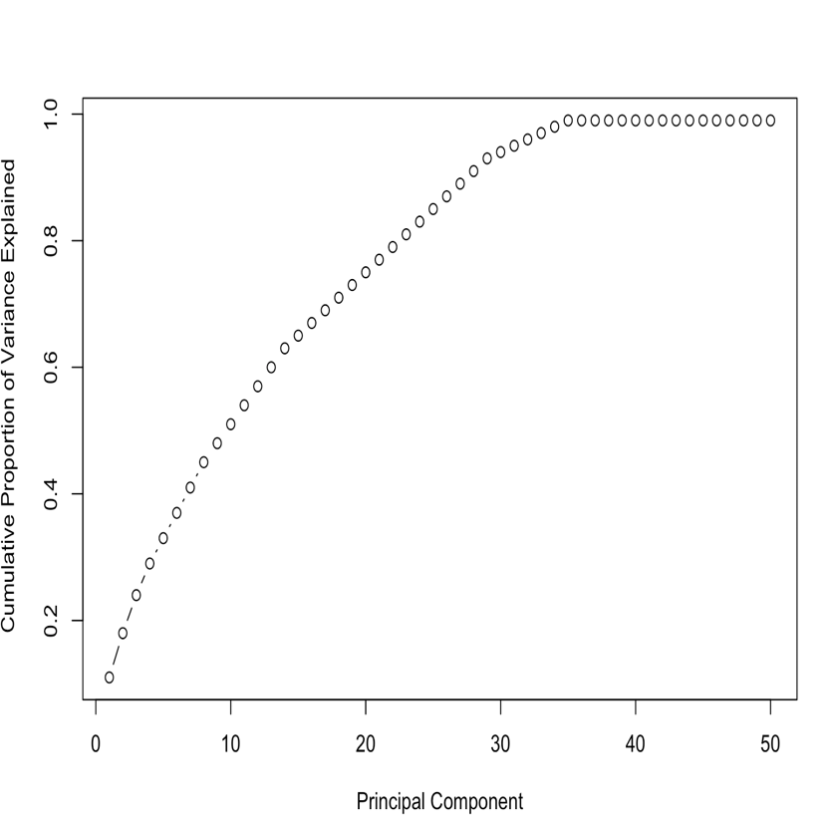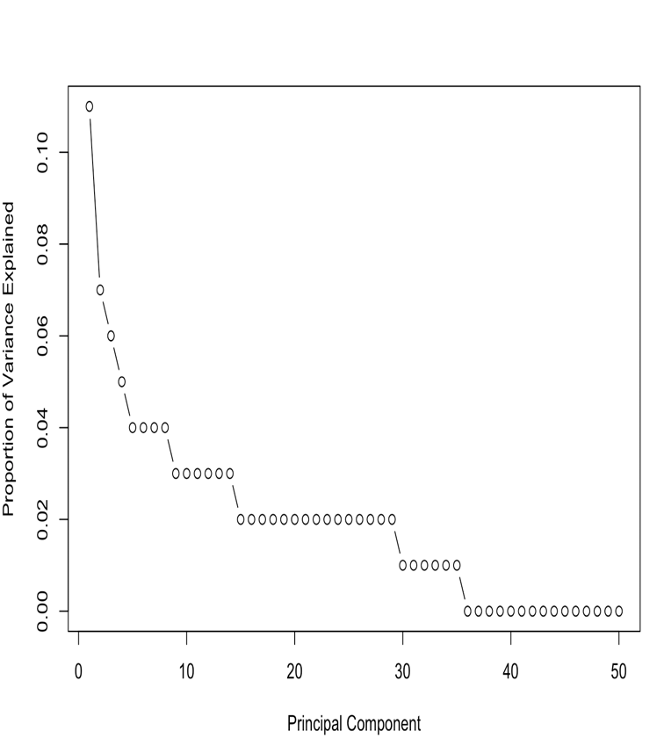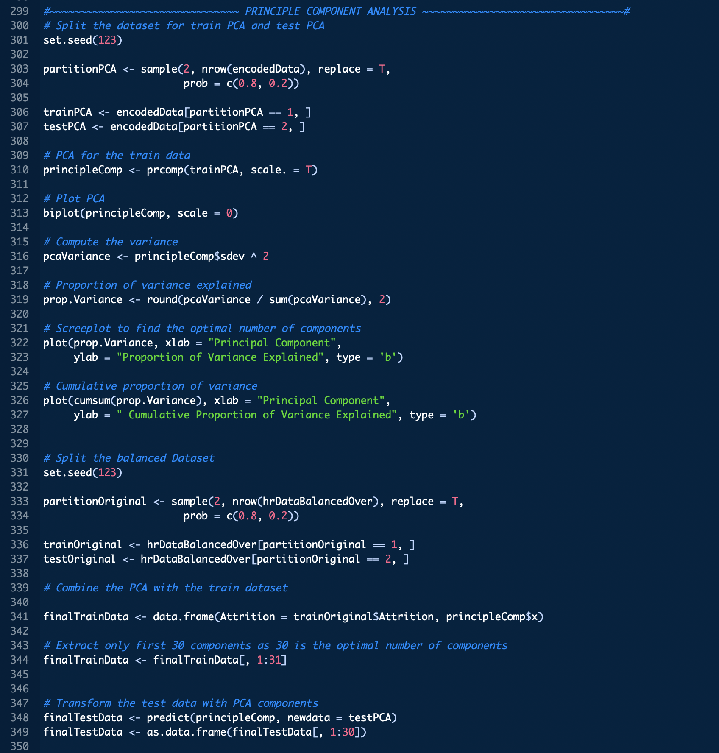

**Modeling**

After dealing with the data exploration and data pre-processing, the data is ready to build the models to predict the employee attrition. As stated earlier here I am focused on building model using decision tree, logistic regression, and random forest. Let’s see how these models are performing in predicting the employee attrition.

*Decision Tree*

I used the **rpart** library. To train and fit the model to the training dataset. The **classification method** is used to train the model. The trained model is used to predict the test data to track, how the model is performing in the unseen dataset.

The Overall accuracy of the model is **79%** which is good. The sensitivity rate is 81% and Specificity is 77%. (i.e.) 81% of the time the model is able to correctly predict the employee will leave company. It is also performing well in predicting the employee who will stay in the organization. 77% of the time the model is predicting the employee will stay in the company. Overall the decision tree model is performing good.

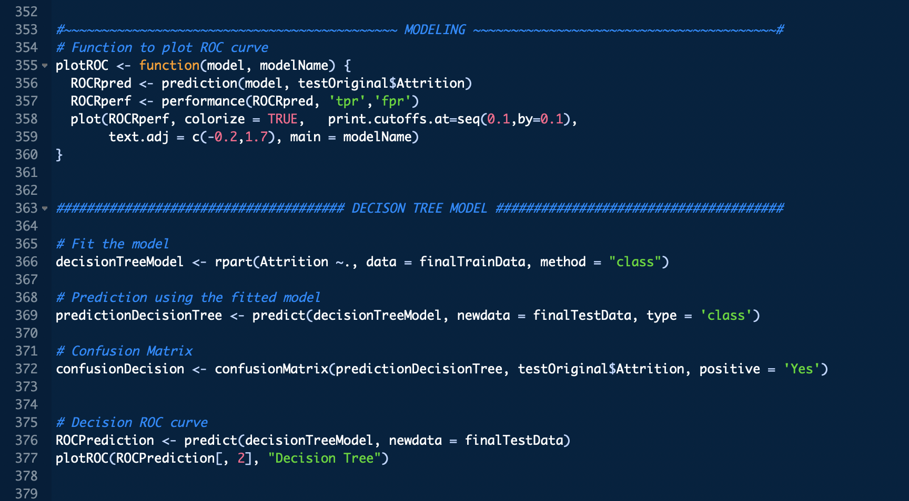

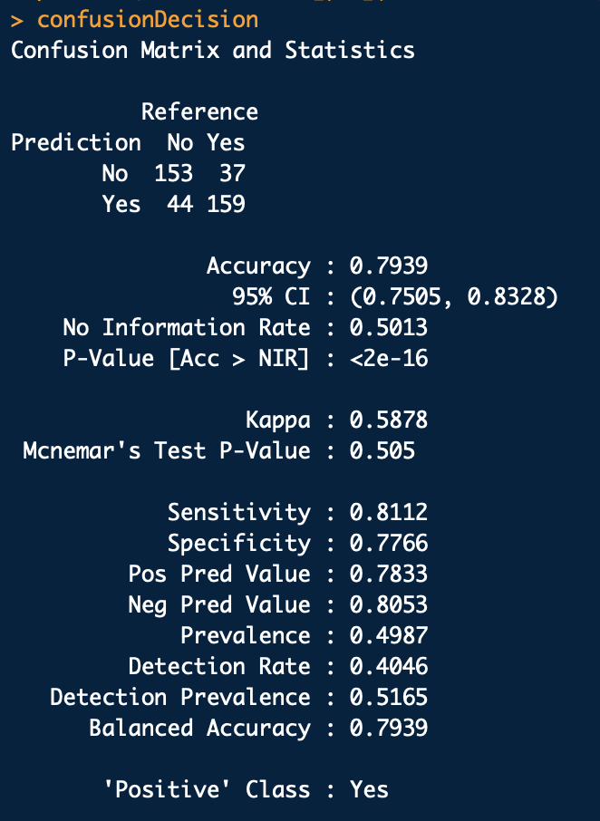

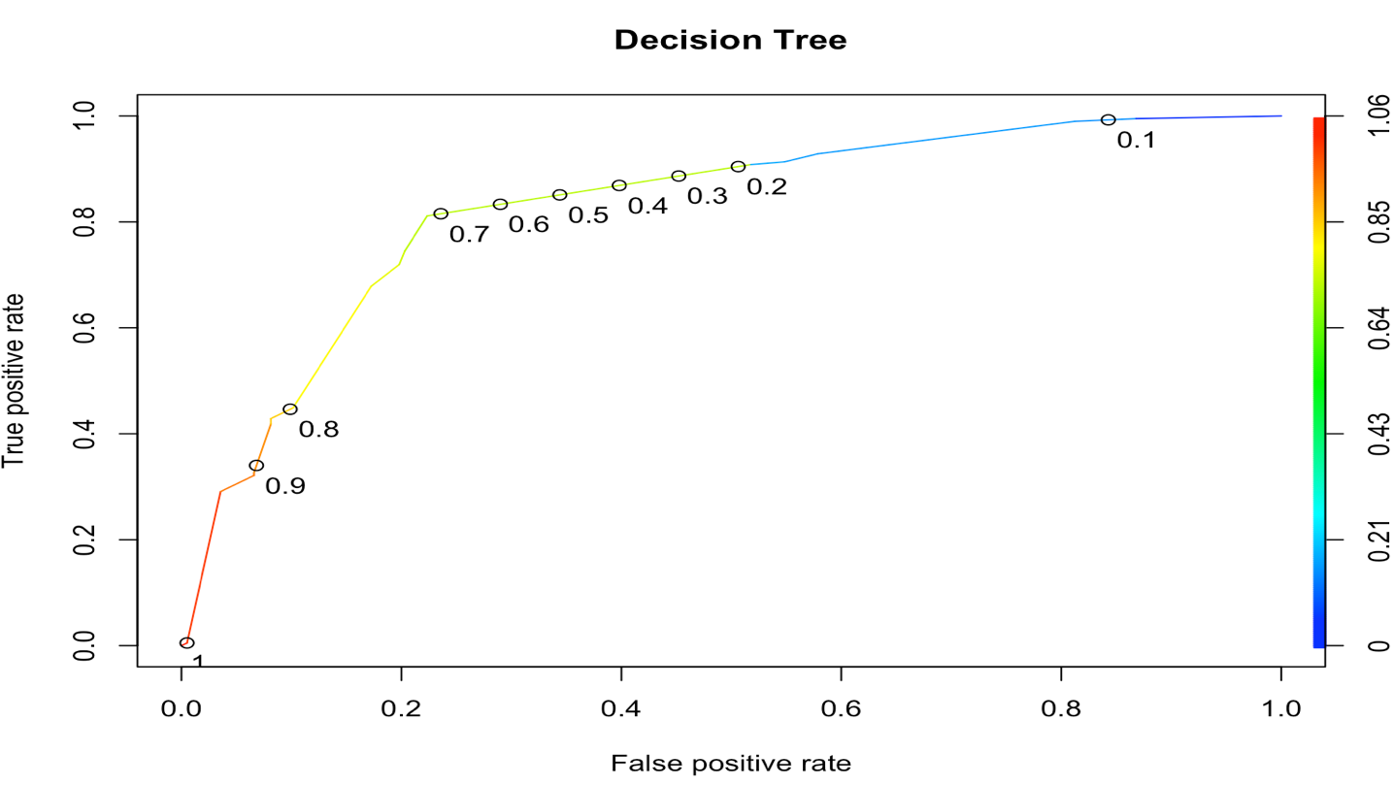

*Logistic regression*

Looking at the confusion matrix, this model provides the accuracy rate of **76%.** I am 95% confidence that this model will correctly predict the employee attrition with an accuracy range from 71% to 80%. The sensitivity (77%) and specificity (76%) value are also reasonable. However, it is comparatively less than decision tree. May be if we consider the optimal cut off value between 0.5 to 0.6 would help to increase these accuracies.

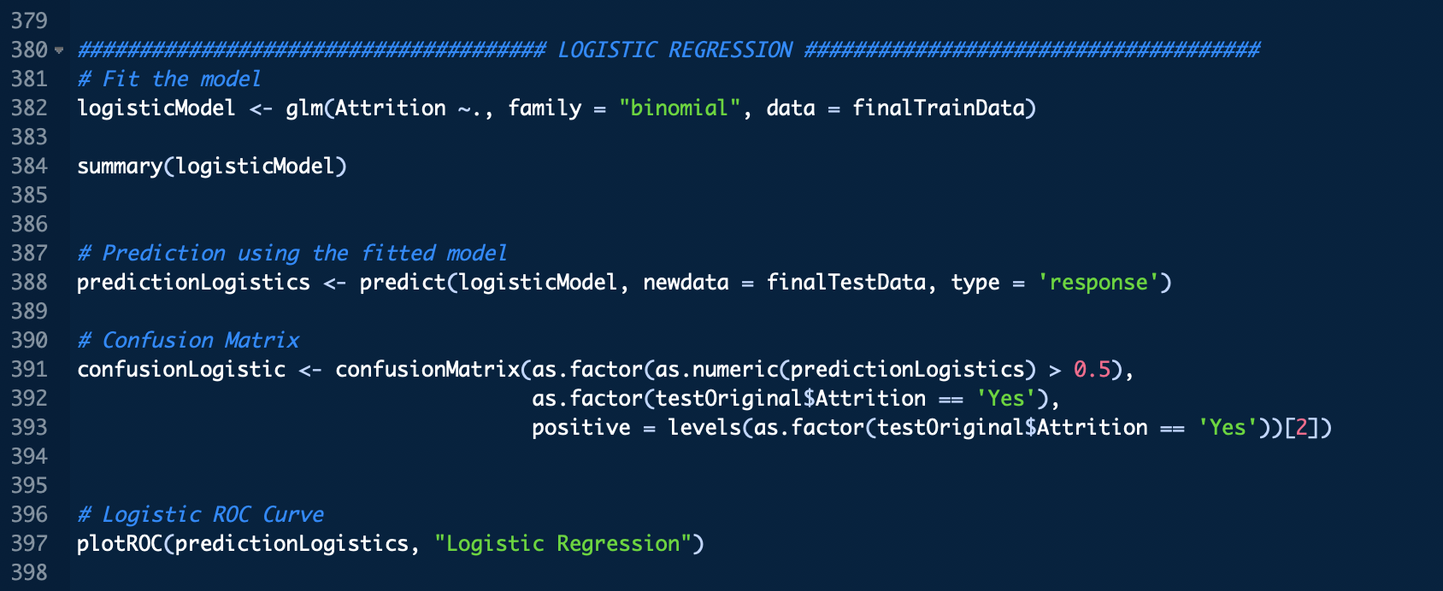

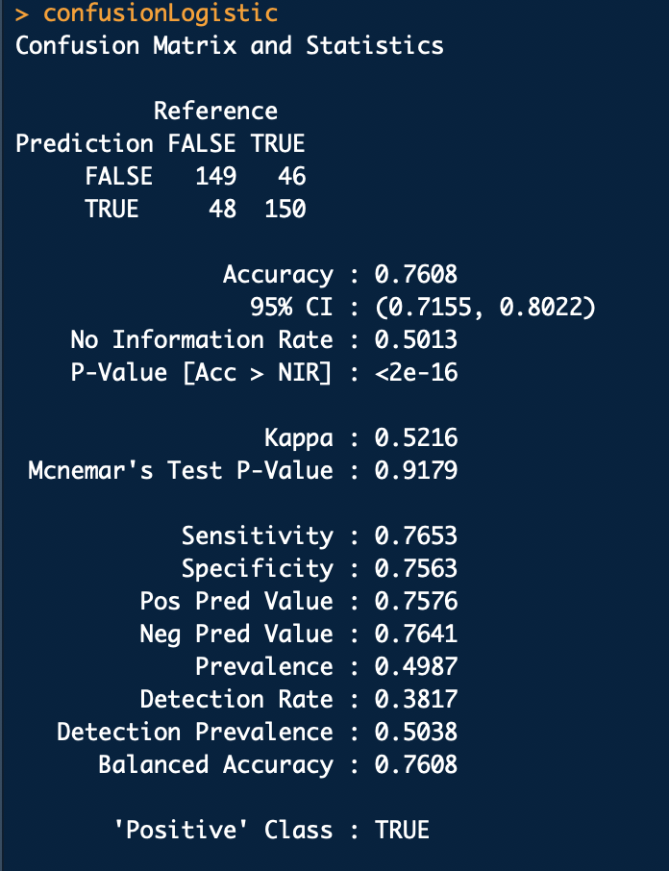

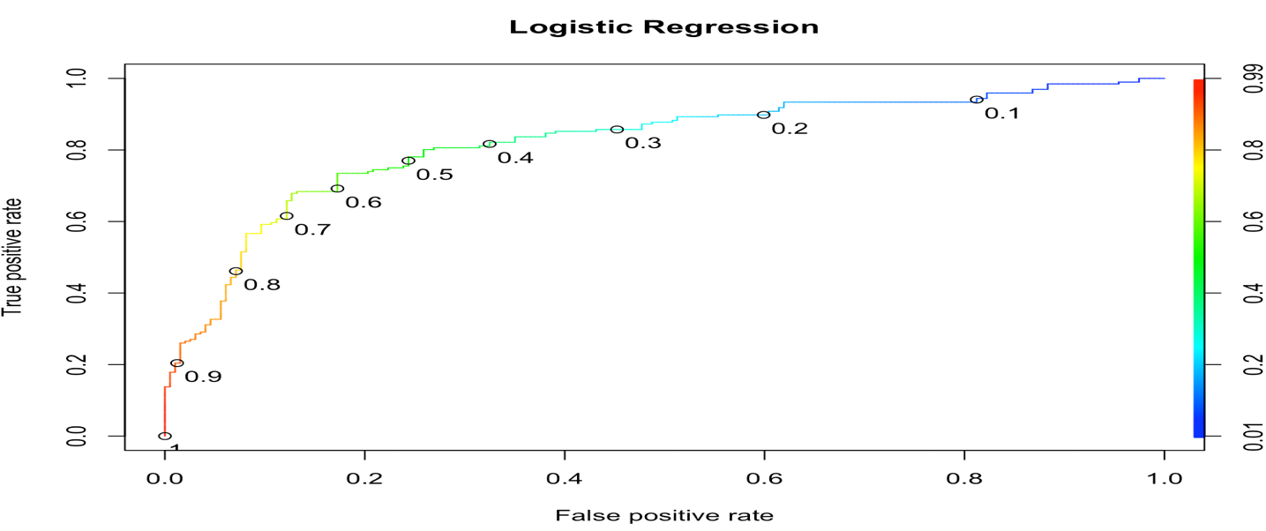

*Random forest*

In this model, I used 150 trees for classification to optimize the model. The accuracy of the model build using random forest is **98 %** with average **out of bag error rate of 0.03**. This represent the model is highly reliable. Looking at the sensitivity and specificity value of each class, it is evident that the model classifies the class appropriately. (i.e.) It is rightly identifying class ‘Yes’ as ‘Yes’ and class ‘No’ as ‘No’. The ROC curve implies how the model is performing by increasing the true positive rate and minimizing the false positive rate.

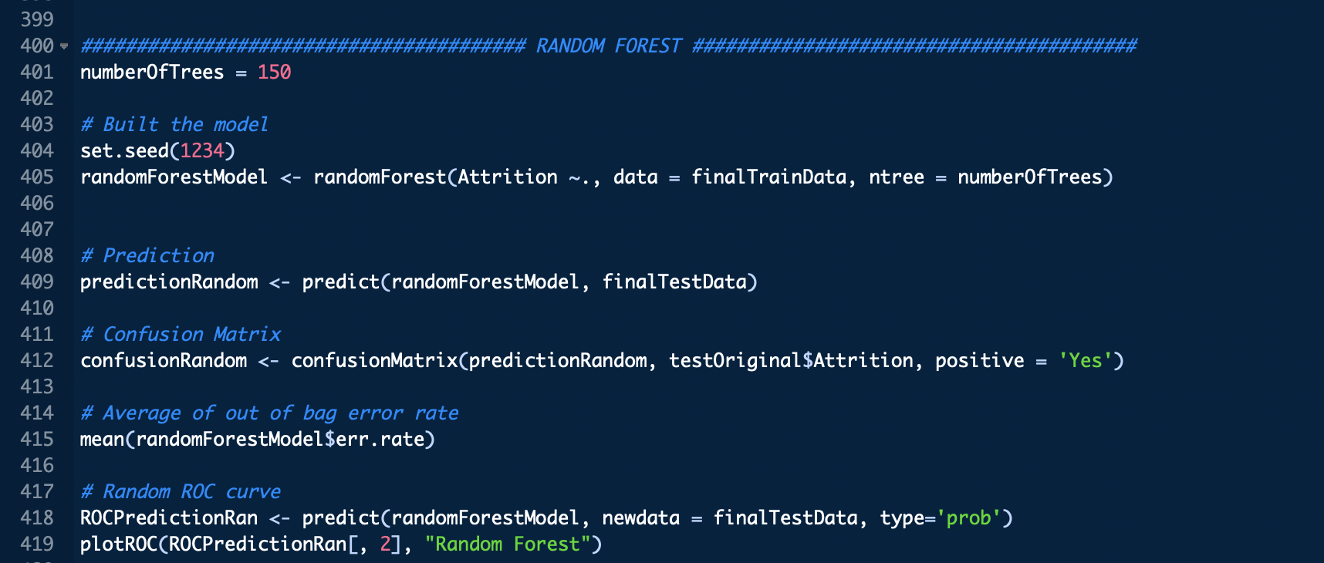



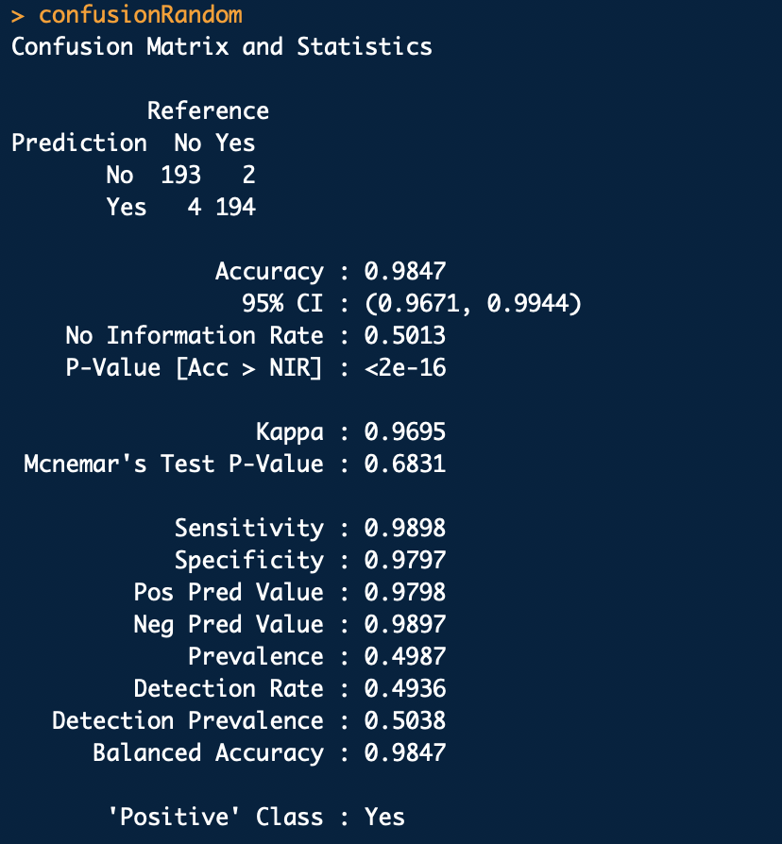

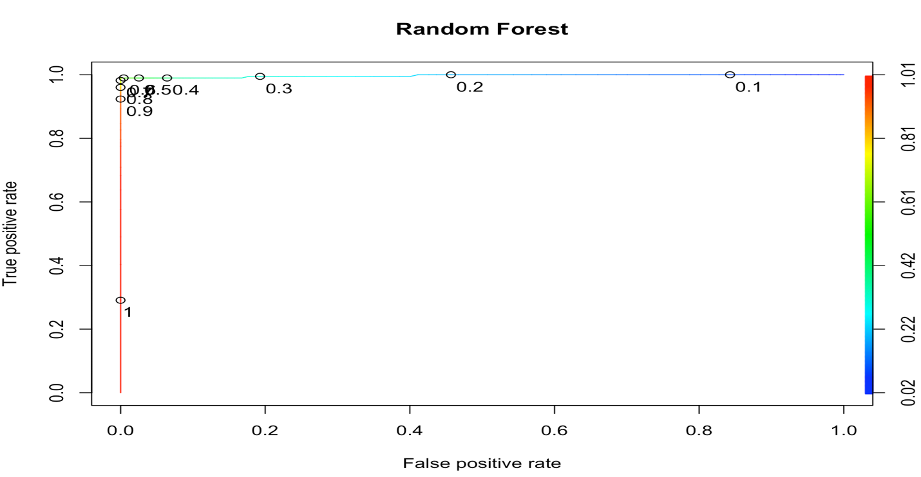

**Model Evaluation**

Finally, after building various classifications models, lets evaluate the models using various metrics such as precision, recall, and accuracy. Looking the at the below metric, we could see both Decision tree and random forest provide the same values. However, looking at the accuracy of the model, ***Random Forest (98%)*** is the best model to predict the employee attrition.

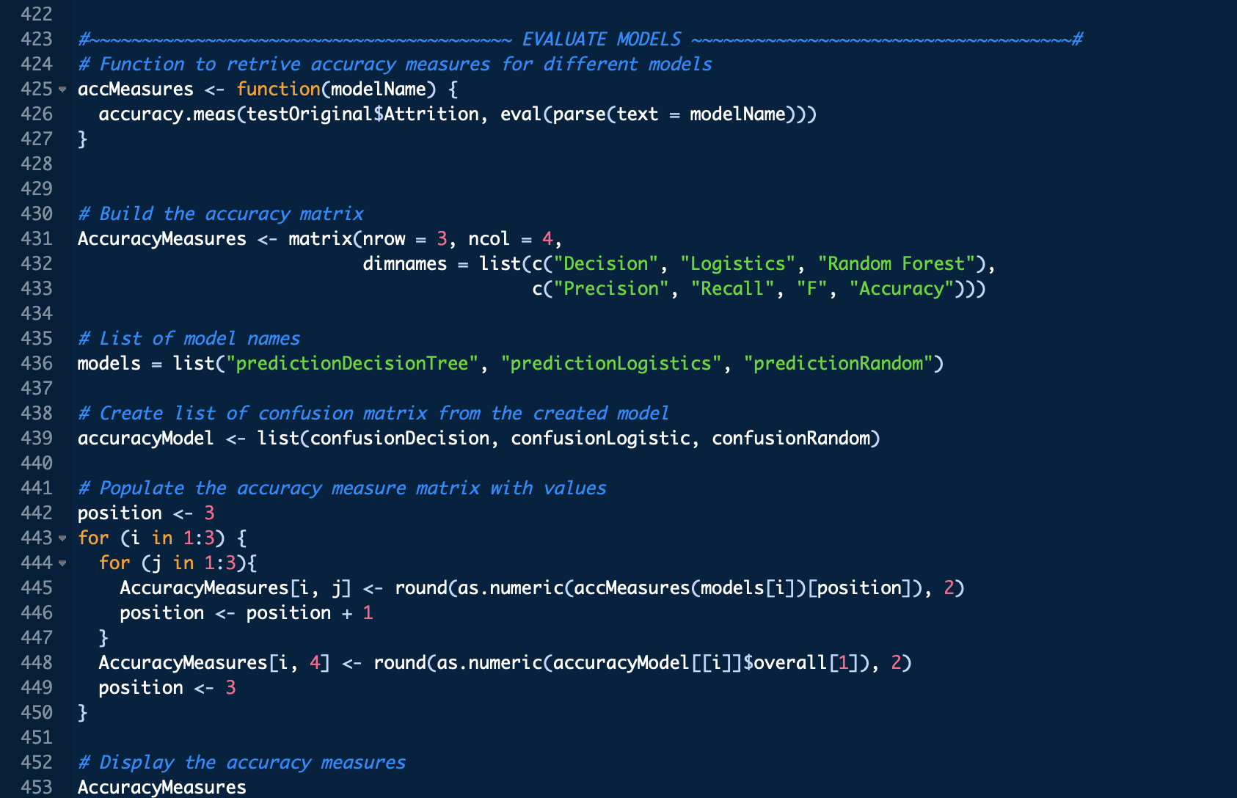

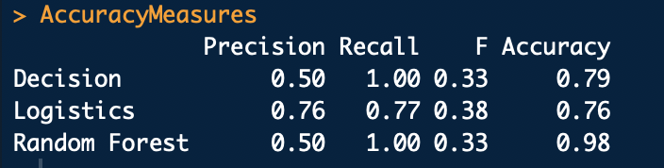

**Conclusion**

In this project I have explored all the phase of data mining life cycle such as **data exploration/Analysis, data preparation, modeling and evaluation** etc. using R. I have used various libraries/package (**ggplot2, caret, dplyr, dummies, etc**. to name the few) and **created few functions** for code reusability. Encountered few data issues like imbalanced data, multicollinearity. I used oversampling and PCA techniques to overcome these issues.

In future, I would look to optimize the models using other advanced techniques/algorithms such as synthetic data generation (SMOTE) to deal with imbalanced data, and gradient boosting algorithm to see how this algorithm is performing in terms of classification for unseen data.